# Wahoo Website Archive

## August 2018

## PROJECT OVERVIEW

#### PHASE 1 TIMELINE

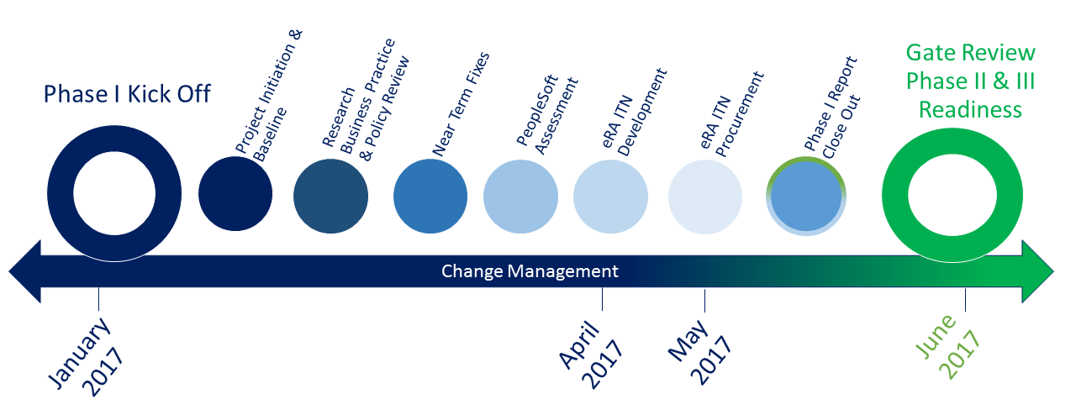

#### Phase 1 Scope

Research Administration, Pre & Post Award Accounting business process review and design for industry best practices implementation

* Research Business Practice and Policy Review Assessment – Documentation review, interviews, research operations walk through, integrated review of Pre-Award, Post-Award and Grants Accounting, review of current state and To Be future state in policies, processes and procedures, Organizational structure review and analysis
* Electronic Research Administration (eRA) RFP development and Vendor Selection
* UCF Financials / PeopleSoft Environment Review and Assessment for Grants Implementation and Optimization
* Change Management Planning for Organizational & Technology Change

#### Phase 2 Scope

* Implement PeopleSoft Grants Post Award Module
* Change Management
* Training initiatives

#### Phase 3 Scope

* eRA System Implementation and PeopleSoft integration
* Change Management
* Training initiatives

## ANNOUNCEMENTS

### PROJECT WAHOO VENDOR DEMOS

#### INTRODUCTION:

UCF is currently undertaking a multi-year, multi-phased project focused on the University-wide restructuring of research administration business processes and technologies to support Principal Investigators (PI) and UCF’s research enterprise. As part of Phase II of this project, we will begin reviewing electronic research administration (eRA) system vendor proposals and will be soliciting your participation in vendor system demonstrations.

Details on the ITN 1628JCSA are available [here](https://procurement.ucf.edu/wp-content/uploads/sites/3/2017/06/ITN1628JCSA-ORC-ERA-System-Final.pdf).

#### VENDOR DEMOS ARE SCHEDULED FOR THE FOLLOWING DATES AND TIMES:

|  |  |
| --- | --- |
| [http://wahoo.research.ucf.edu/img/huron.jpg](http://wahoo.research.ucf.edu/calendar/ProjectDemoHuron.ics) | Huron Consulting Services, LLC *8/15/2017 01:00 PM* |
| [http://wahoo.research.ucf.edu/img/cayuse.png](http://wahoo.research.ucf.edu/calendar/ProjectDemocayuse.ics) | Cayuse, Inc *8/16/2017 08:30 AM* |
| [http://wahoo.research.ucf.edu/img/streamlyne.png](http://wahoo.research.ucf.edu/calendar/ProjectDemostreamlyne.ics) | Streamlyne *8/16/2017 01:00 PM* |

#### LIVE STREAMING:

Live video streaming of the sessions will be made available [here](http://webcast.oir.ucf.edu/).

#### SURVEY:

We kindly invite you to attend the sessions and provide your feedback using the short Qualtrics survey [here](http://ucf.qualtrics.com/jfe/form/SV_2hj8he56oqspId7).

Your participation in the selection process will be crucial to choosing an eRA system that best meets the needs of UCF research community and supports UCF on achieving our strategic goals.